Chapter 14, Solution 21.

H(ω) = 10(jω)(20+jω)/[(1+jω)(400+60jω–ω²)]

= [10x20/400](jω)(1+jω/20)/[(1+jω)(1+(3jω/20)+(jω/20)²)]

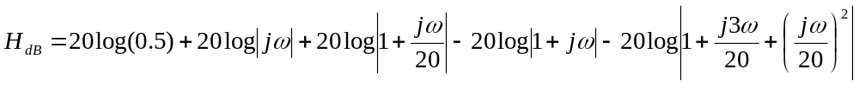
The magnitude plot is as sketched below. 20log₁₀|0.5| = –6 db

1
0.1
db
10
100
ω
20
20 log 0.5
20 log |1+jω/20|
–20 log
40
–40
–60
–80
–20 log
20
–20
20log|jω|

